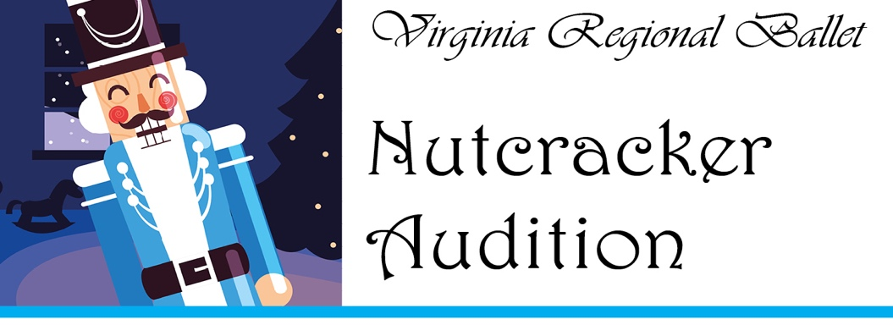
VRB use only
Fee pd: #

Registration Form

Dancer’s Name: Gender: M F _________
Date of Birth: Height:
Address: City: Zip:
Parent/Guardian’s Name:
Home Phone: Work/Mobile Phone:
Dancer’s E-Mail: Parent E-Mail (if different):
2021-2022 School attending: 2021-2022 Grade:
Dance Training: (number of years, company/studio)

Performance Experience:

I understand that if I am selected for the 2021 Nutcracker Production, I commit…
- to attend all scheduled rehearsals and performances, except with written permission from the artistic director. Rehearsals begin the second week of October.
- to not participate in any other activity that may interfere with rehearsals/performances.
- to pay all costume fees, due upon request.
- to regularly attend the required ballet technique/pointe classes expected of my level.
- to check the bulletins, website, or call the studio each week to confirm rehearsal times and dates.

Please note: Casting is not solely based on the audition, but on the overall progress made during the summer months of ballet training. All parents are asked to volunteer.

Signature of Dancer: Date:

Signature of Parent/Guardian: Date:

$25.00 Audition Fee, cash or check payable to Virginia Regional Ballet
Dancers must continue with ballet training through the summer. Non-VRB dancers will be asked to show written summer evaluations from current ballet teacher. Dancers will be notified of acceptance in Aug. and casting in early September; Cast List will be posted at VRB’s Annual Fall Family Potluck in early September.

2021 Nutcracker performances are at Ferguson Center for the Arts, Newport News, in mid-December. The schedule includes two educational performances on a week day at 11:00 a.m. The tech rehearsal is Wednesday from 5:00-11:00 p.m. Dress rehearsal with orchestra is Friday from 7:00-10:00 p.m. Public performances are on a Saturday at 1:00 & 5:00 p.m.

Virginia Regional Ballet • 1228 Richmond Road, Williamsburg, VA 23185 • 757.229.2553 • www.danceVRB.com

