2021
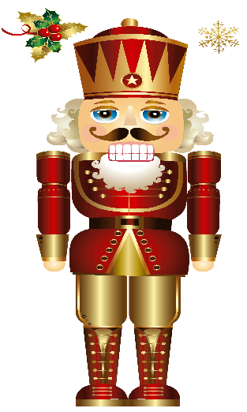
Due: October 4, 2021
While these are not the only nutcrackers that will be available for sale at the Merchandise Table in December, we wanted to give VRB families the chance to get first pick! Nutcrackers may be paid for and picked up by parents during dress rehearsal.
**Disclaimer: Nutcracker orders are subject to availability from the vendor. You will be contacted should your selected nutcracker be out of stock. Also, orders will be given in the order forms are received. **
Socks ______________________________________ Qty ______X $10 Total $________
Mini Snow Globes Qty ______X $10 Total: $________
Musical Snow Globes Qty ______X $15 Total: $________
10’’ Two toned Lavender Nutcracker Qty _____ X $16 Total: $________
12’’ Cupcake Hat Nutcracker Qty ______ X $20 Total: $________
10” Rose Gold Soldier Nutcracker Qty ______ X $20 Total $________
14” Snow Queen Nutcracker Qty ______ X $25 Total $________
10” Drosselmeyer Nutcracker Qty ______ X $20 Total: $________
10” Candy Cane Purple/Pink Nutcracker Qty ______ X $16 Total: $________
12” Soldier Pride Nutcracker Qty _____ X $20 Total: $________
10’’ White Gold Metallic Nutcracker Qty ______ X $14 Total: $________
10” Two Tone Teal Nutcracker Qty______ X $16 Total: $________
10” Angel Fairy Nutcracker Qty ______ X $20 Total: $________
10” Mouse King Nutcracker Qty ______ X $20 Total: $________

10” White/Black Polka Dot Nutcracker Qty ______ X $14 Total: $________

14” Plush Characters Qty _______x $20 Total $_________
Ornaments __________________________________ Qty_______X $12 Total $________

Name: ____________________________________ Phone: _______________________
Email: ____________________________________ Total Amount: $________________

