2021 Nutcracker Pre-Order Pictures

Socks:

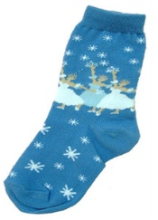 Snow Queen Clara and Nutcracker Mouse King

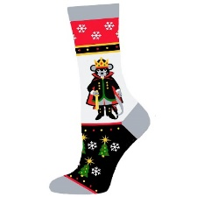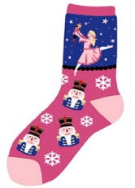

Nutcrackers:

10” Two Toned Lavender 12” Cupcake Hat 10” Rose Gold 14”Snow Queen

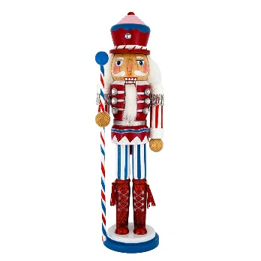[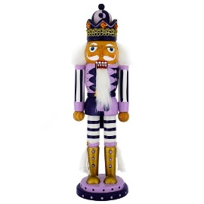](https://www.nutcrackerballetgifts.com/product/N1023-A/King-Nutcracker-Two-Tone-Lavender-Violet-and-Crown-10-inch.html?cid=5)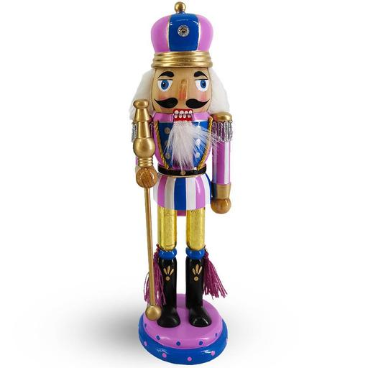 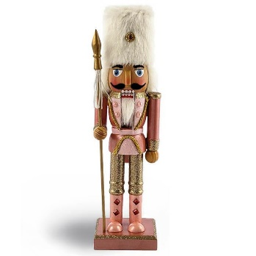 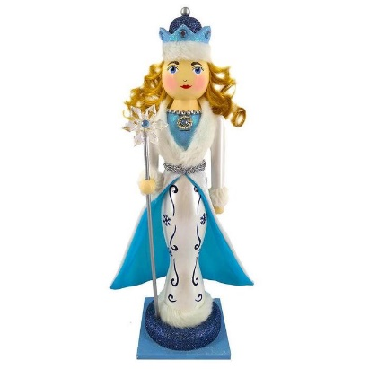

10” Drosselmeyer 10” Pink/Purple Candy Cane 12” Soldier Pride 10” White Gold Metallic

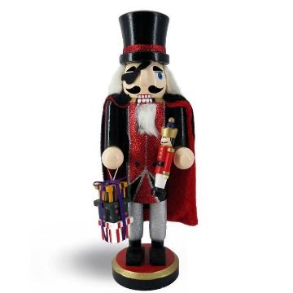 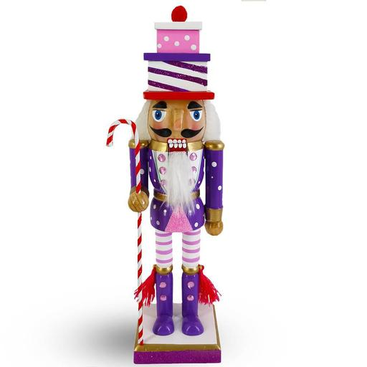 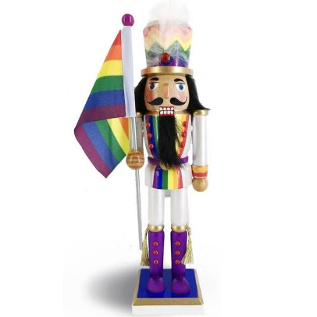 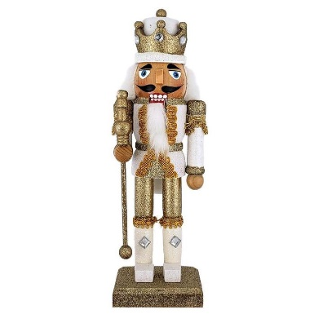10” Two Toned Teal 10” Angel Fairy 10” Mouse King 10” White Black Polka Dot

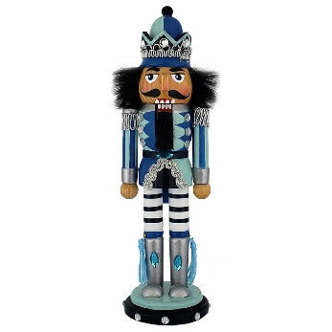 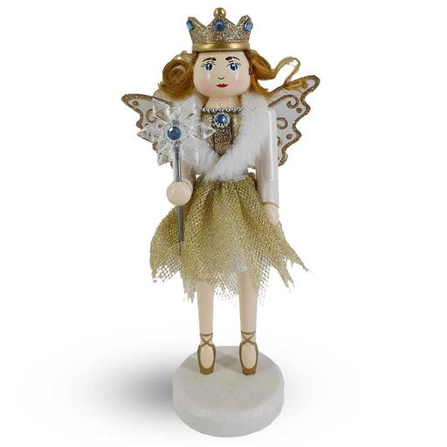 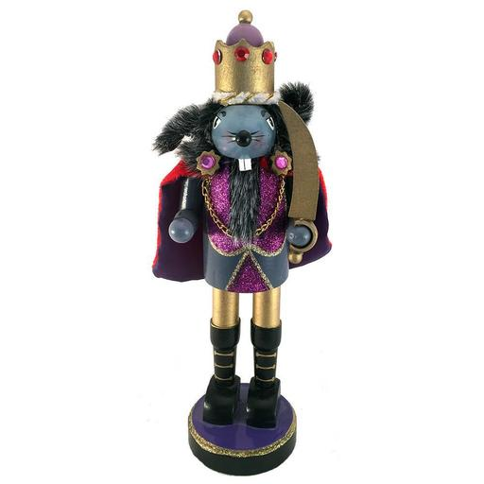 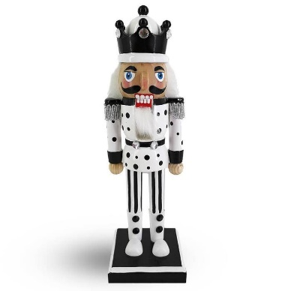

Snow Globes:

Musical Nutcracker Musical Sugar Plum Musical Mouse King

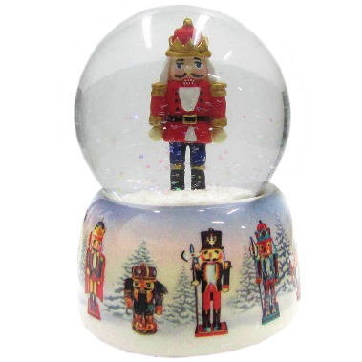 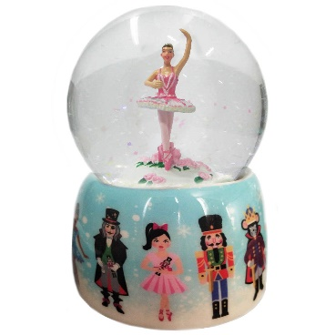 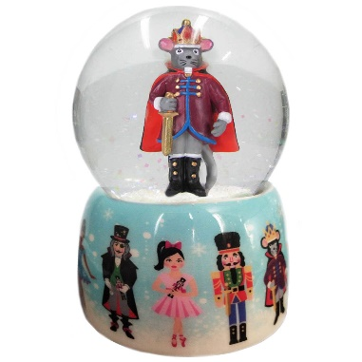

Mini Ballerina Mini Snow Queen Mini Nutcracker Mini Chinese Mini Arabian

[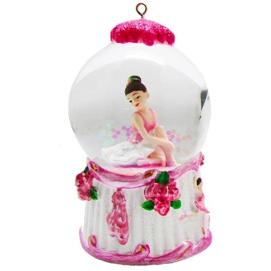](https://www.nutcrackerballetgifts.com/product/SG-BAL45WG/Mini-Ballerina-Pink-and-White-Snow-Globe-Ornament.html?cid=42) [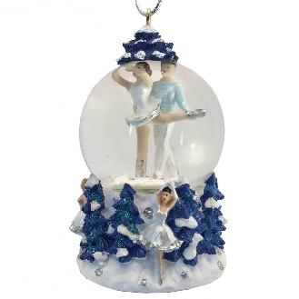](https://www.nutcrackerballetgifts.com/product/SG-45mmSN/Mini-Snow-Queen-Pas-de-Deux-Snow-Globe-Ornament.html?cid=42) [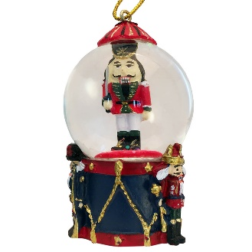](https://www.nutcrackerballetgifts.com/product/SG-45mmNUT/Mini-Nutcracker-Soldier-on-Drum-Snow-Globe-Ornament.html?cid=42) [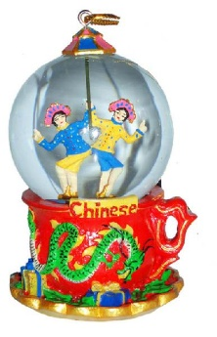](https://www.nutcrackerballetgifts.com/product/SG-45mmCH/Mini-Chinese-Dancers-Snow-Globe-Ornament.html?cid=42) 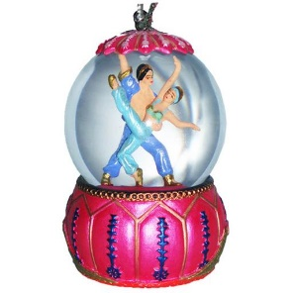

Ornaments:

Mother Gigogne Nutcracker #1 Mouse King Klara Nutcracker #2

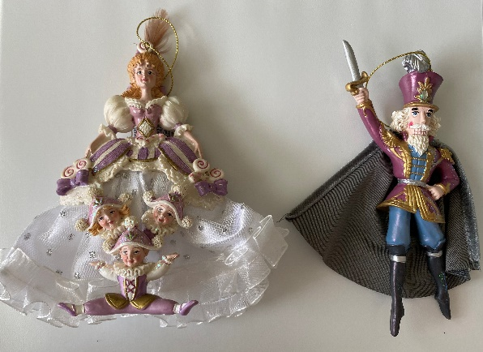 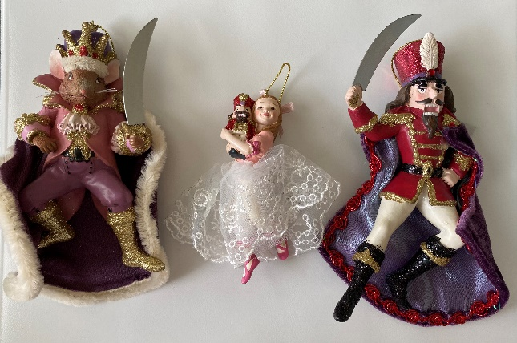

Plush:

Klara Nutcracker Mouse King 