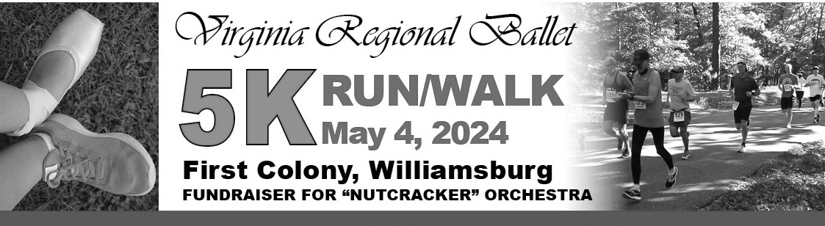

Saturday - May 4, 2024
Seventh Annual 5K Run/Walk and 1 Mile Fun Run/Walk
First Colony Neighborhood, Williamsburg, Virginia
A COLONIAL ROAD RUNNERS GRAND PRIX EVENT

Proceeds and sponsorships benefit efforts for a live orchestra for the 2024 production of “The Nutcracker.”
Virginia Regional Ballet, Inc., is a nonprofit 501(c)(3) organization.

Schedule: 7:00 a.m. Race day registration and packet pick-up at
First Colony Pavilion, adjacent to pool and parking areas
8:00 a.m. One Mile Fun Run/Walk
8:30 a.m. 5K Run/Walk
9:45 a.m. Awards Ceremony

Location: First Colony Pavilion, 125 Pasbehegh Dr., Williamsburg, Virginia, off Route 5/John Tyler Highway, Williamsburg, VA 23185

Course: The First Colony 5K course is a counterclockwise loop of the beautiful, tree-lined First Colony neighborhood, on mostly flat, paved asphalt. Starting and finishing near the First Colony Pavilion, the 5K includes Pasbehegh Drive, John Rolfe Lane, and The Maine, with a loop into Jordan’s Journey and Barrows Mount.

Registration: Entries postmarked by April 25, 2024, are $25 per adult for the 5K. Registration for both runs includes a T-shirt. Online individual registration at www.RunSignUp.com through May 3 at 11:59 p.m. Late and race day registration for all entrants are $30 per person. Fee for the One Mile Fun Run/Walk is $10.00 ($5.00 without a shirt). First Colony residents may register for the 5K for $15 and the Fun Run/Walk for $8.00 and includes a T-shirt.

About Virginia Regional Ballet, Inc.
Virginia Regional Ballet, Inc., is a nonprofit organization that sponsors the Virginia Regional Ballet Academy, whose purpose is
to bring educational and cultural dance programs to the Hampton Roads area. This 5K event helps to raise funds to include a live orchestra for the annual “Nutcracker” performances at The Ferguson Center for the Arts in Newport News. Virginia Regional Ballet is dedicated to the continued improvement and enhancement of classical ballet technique, offering beginning through
pre-professional training in all dance forms through classes and performance opportunities. Scholarships are available for deserving students interested in dance. THANK YOU for partnering with us!

PLEASE PRINT 2024 Virginia Regional Ballet 5K REGISTRATION FORM

Make check payable to: Virginia Regional Ballet, Inc.
Registration may be dropped off or mailed to:
Virginia Regional Ballet, 1228 Richmond Rd., Williamsburg, VA 23185

Circle Adult T-Shirt Size: Circle Race Entered:
Adult S M L XL 5K RUN 5K WALK 1 MILE
Youth S YM YL

Name______________________________________________________________________________ M___ F ___ Age (on race day) ___________________
Address________________________________________________________________________________________________________________________________
City/State/Zip Code___________________________________________________________________________________________________________________
Telephone ___________________________________________________________________E-Mail __________________________________________________
I know that running/walking a road race is a potentially hazardous activity. I should not enter a run/walk unless I am medically able and properly trained. I agree to abide by any decision of a race official relative to my ability to safely complete the run/walk. I assume all risks associated with running/walking in this event including, but not limited to, falls, contact with other participants, the effects of the weather, including heat and humidity, traffic and conditions of the trail, all such risks being known and appreciated by me. Having read this waiver, knowing these facts and in consideration of your accepting my entry, I, myself, and anyone entitled to act on my behalf, waive and release the Colonial Road Runners, Virginia Regional Ballet, Inc., First Colony, James City County, and all sponsors, their representatives and successors from all claims or liabilities of any kind arising out of my participation in this event. This is a road race conducted under the rules of the RRCA and USATF. In consideration of the safety of all participants, please, no baby joggers, headphones, animals on leashes, skateboards or skates.

Signature_____________________________________________________________________________________________Date_____________________
All entrants must sign waiver (parent or guardian signature required if under 18)

Participant Race Package:
The first 150 registrants will receive a short sleeve T-shirt.
Race day entrants will receive T-shirts while supply lasts.
Awards:
- Top three overall female and male runners in the 5K
- Top three females and males in five year age groups from 14-and-under through 70+ for women and men
- Top three female and male walkers in the 5K

Refreshments: Post-race refreshments include: bagels, bananas, apples, oranges, sports drinks, and water.
Directions: The First Colony Clubhouse and Pavilion are located at 125 Pasbehegh Dr. First entrance: Directions from Route 199. Turn onto John Tyler Highway/VA-Route 5, travel 3.8 miles to Greensprings Rd. Turn left onto Greensprings Rd. Travel 0.6 mile turn right onto The Maine travel 0.2 mile turn right onto Pasbehegh Dr. The Pavilion will be on right.
Second entrance: Directions from Route 199. Turn onto John Tyler Highway/VA-Route 5, travel 4.0 miles to John Rolfe (the main entrance into the neighborhood). Travel down John Rolfe, to a left onto Pasbehegh Dr., and follow to the Pavilion, which will be on your left side.
Alternative from Jamestown Road: From Route 199, take Jamestown Road west to a right onto 4-H Club Road (after Jamestown 1607), then take a right onto Greensprings Road. Take a left onto The Maine, and travel 0.2 mile and turn right onto Pasbehegh Dr., to the First Colony Pavilion.
